Our Vision 2021–2025 CoLibri

„Where are we heading and what do we want to achieve. ” Elementary, kindergarten and high school

Our Colibri school is a stable, succesfull and prosperous project. It stands firm on its principles, which are: TRUST, RESPECT, FREEDOM AND RESPONSIBILITY. These principles are intertwined with the daily life of the school, radiate outwards and become a natural part of people's lives in and around the school. The school community is a diverse, age-diversed group of girls, boys, women and men who enjoy being together, who are respectfull and supportive towards each other. Our school is imbued with a sense of belonging, cooperation and security. The common feeling of all children and adults is pride in what kind of school we create together.
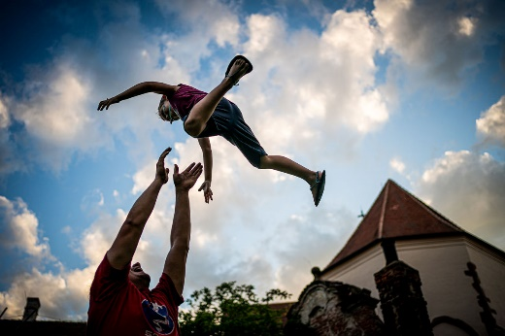

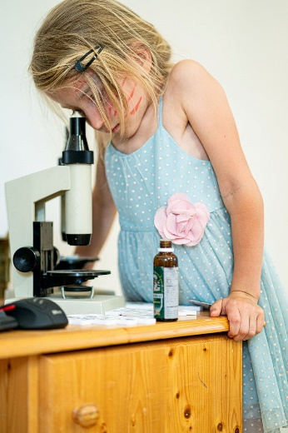
SELF-DIRECTED EDUCATION
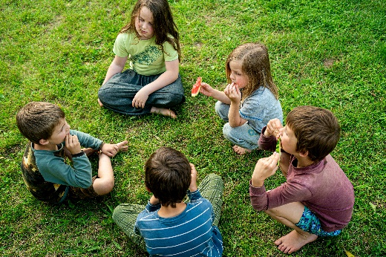
We believe that each of us has our own unique talents and gifts, and our school offers a supportive, safe, stimulating and diverse environment where everyone can discover and develop their own. We support the natural human desire to know the world and create a space that allows us to maintain the joy of learning.
The children choose the lessons and activities in which to participate. Free play and relaxation is an integral part of school days. The offer of lessons, courses and thematic workshops is continuously adjusted according to the current interest of children. Thanks to the mixed-age team, children learn from each other.

DEMOCRATIC STRUCTURE OF THE SCHOOL
The school is governed by a School Meeting, which proposes and approves all the rules and manages the day-to-day running of the school. Every member of the school community, children and adults, has an equal vote in the Meeting.
All members of the school are active creators of what is happening at the school, they learn to deal with their freedom and they are responsible for their actions.

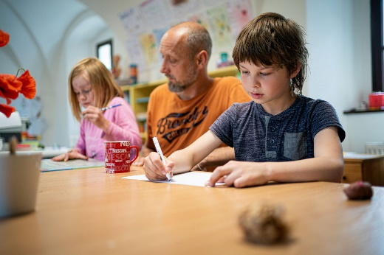
SCHOOL TEAM
CoLibri has a diverse, stable, mutually supportive and complementary team of adults. All team members are in line with the principles and values of the school and are good role models for "free and responsible people". These adults are proficient in nonviolent communication and respectful attitudes and are internally motivated to work in our school. Working in a team is based on trust, openness, authenticity and mutual respect.
Team members work together to create and maintain a safe, supportive, colorful and inspiring environment in which children feel comfortable. Together with the children, they provide everything needed for the smooth running of the school.

WIDER SCHOOL COMMUNITY
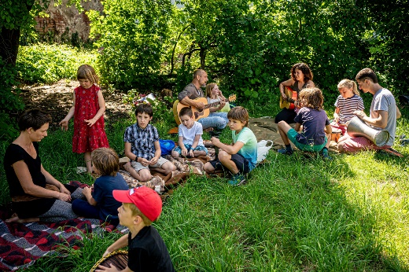
CoLibri attracts similarly attuned families who are close to the principles of self-directed education. The parents of our children believe that children are competent to manage their education, their lives and the school itself. They are people open to new perspectives, willing to learn and grow.

There is a friendly, safe and supportive atmosphere in the wider school community. The school creates a space for parents to share experiences and topics related to self-directed education and maintains open communication with parents.
Various events are organized for the wider school community – common trips, expeditions, festivities, an adaptation weekend and a summer camp during the summer holidays.

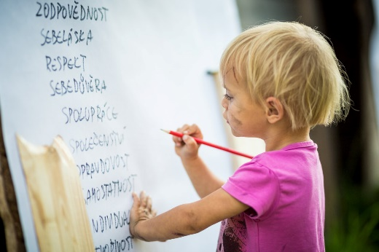
SCHOOL CAPACITY
Every year, the general awareness and interest in self-directed education increases. We always have enough people to fill our capacities. Every year we accept 5-8 new children. We want our school to maintain a family atmosphere, therefore the final planned capacity for full-time study is 60-90 pupils in the age range of 4 to 19 years. In addition to this capacity, we accept homeschooled children who are in line with the educational concept of our school.

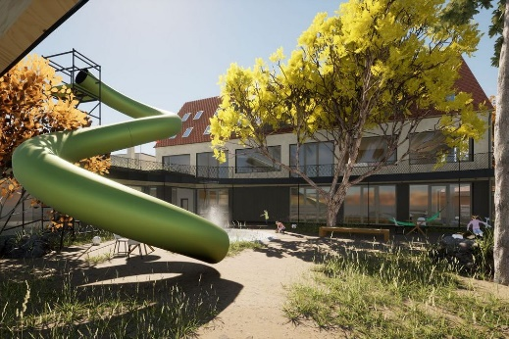
SCHOOL FACILITIES
The school has a beautiful new school building on Uhrova Street in Předklášteří. This building is designed in accordance with the specific needs of our school and offers an above-standard connection of the interior with the neighbouring garden. We have plenty of places to meet, a large room for school meetings, many small classes for individual tuition, a relaxation room, a playroom, a dressing room, a study, a kitchen with a dining room, a workroom, a studio and a beautiful garden. The school space is pleasant, practically furnished, representative and every member of the school community feels welcomed and accepted here.
The school has a stable lunch supplier who prepares excellent food from local ingredients for us.
The school building also serves as a community center, where weekend and afternoon seminars focusing primarily on the education of children and adults take place.

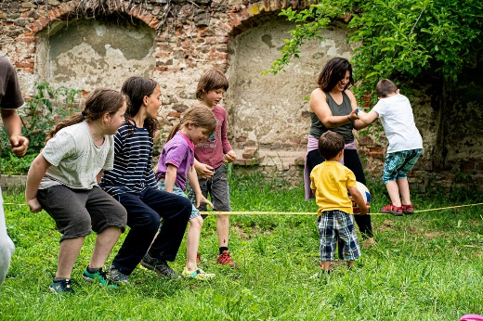
FINANCIAL STABILITY
CoLibri is prospering financially. We have a balanced budget and we manage to create a reserve for the future. We receive 100% of the education contribution from the state and we successfully pass each additional inspection. We have generous and long-term sponsors, we use financial flows from grants and we actively seek other financial resources and opportunities.
Thanks to sufficient sources of finance and efficient management, we have above-standard salaries of employees and at the same time we manage to keep low tuition fees for a long time. We support multi-child families with significant discounts on tuition for siblings.

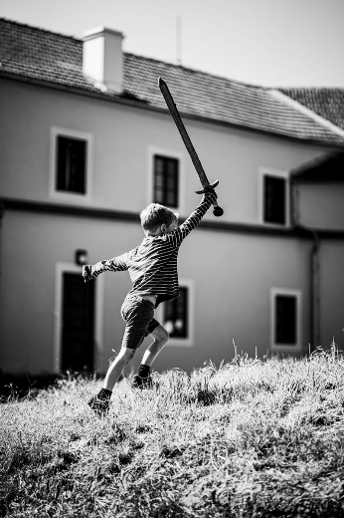
WIDER PUBLIC, CZECH AND INTERNATIONAL CONTEXT
CoLibri has prestige and a good reputation in the context of free schools. We support the establishment and growth of other democratic and free schools. We are actively working to adopt self-directed education as an accepted alternative at the political level, thus creating societal change, not only in the field of education.
We are active members of the Czech and European Association of Free and Democratic Schools. We meet other schools regularly, discuss philosophy, exchange practical experiences, provide feedback to each other and organize exchange stays for children and guides. We are the initiator of grants for cooperation, knowledge transfer and exchange stays of guides and children of similarly oriented schools in the Czech Republic and in the world.
For the general public, we organize, or are invited to, workshops and discussions on topics related to self-directed education. We cooperate with friendly schools and organizations in this adult education. In our founding association Hnízdo, we cultivate good relations and mutual support. Together we strive for meaningful change at the local level.

GRADUATES
Children love school and, thanks to the time spent in it, they grow into free, responsible, healthy, satisfied and self-conscious adults. Our graduates know their value and become active creators of their lives. If they decide to continue their studies at another school, then they have no problem getting to the school of their choice.
Our alumni like to come back to us and some stay in school as team members.
Being in our school is filled with meaningful, lively, joyful energy and gratitude.
Thank you.

